

Creation Of An Application For School Management

**NAAN MUDHALVAN PROJECT REPORT**

***Submitted by***

**UDHAYAPRAKASH P (620120104107)**

**VIGNESH S (620120104109)**

**SUNIL KUMAR T (620120104101)**

**PANNEER SELVAM P (620120103310)**

**RANJITH S (620120104079)**

***in partial fulfilment for the award of the degree of***

# BACHELOR OF ENGINEERING

***in***

# COMPUTER SCIENCE AND ENGINEERING

**AVS COLLEGE OF ENGINEERRING,**

**SALEM – 636003.**

# ANNA UNIVERSITY::CHENNAI 600025

**BONAFIDE CERTIFICATE**

Certified that this the project report titled **“creation of an application using for school management”** is the bonafide work of **“UDHAYAPRAKASH P (611220205008), VIGNESH S (611220205009), PANNEER SELVAM P (611220205023) ,SUNLI KUMAR T (611220205045), RANJITH S (620120104079)”** who carried out the project work under my supervision.

## SIGNATURE

**Prof. S. DHAMODARAN. ME., ASSISTANT PROFESSOR FACULTY MENTOR**

Department of CSE,

AVS College Of Engineering, Military Road,

Salem – 636003.

## SIGNATURE

**Dr. R.VISHWANATHAN M.E., Ph.D.,**

**PROJECT SUPERVICER**

## SPOC FACULTY

Department of Computer Science and Engineering,

AVS College Of Engineering,

Military Road,

Salem – 636003.

## SPOC HEAD OF THE DEPARTMENT

**ACKNOWLEDGEMT**

We would like to express our gratitude and appreciation to all those who gave us the possibility to complete this report. We would like to acknowledge with much appreciation to our honorable Chairman, **Shri.K.KAILASAM**, Secretary, **Shri. K.RAJAVINAYAKAM, MBA**. and also, to our Correspondent, **Shri. K.SENTHILKUMAR, B.Tech**. for providing all necessary facilities for the successful completion of the project.

We have immense pleasure in expressing our gratitude to our beloved Principal, **Dr. A. SRINIVASAN, M.E, Ph.D**., for allowing us to have extensive use of our college facilities to do this project. It gives us a great sense of pleasure in expressing our gratefulness to our beloved Vice Principal’s, **Dr. R. VISWANATHAN, M.E., Ph.D.,** and **Dr. D.R. JOSHUA, M.E., Ph.D.,**

for their professional guidance in scheduling the project work to complete on time.

We express our heartiest gratitude to **Dr. M. VILASINI M.E, Ph.D**., Dean R&D and Head of the Department **Prof. V. MEENA, M.E.,** Computer Science and Engineering, for her guidance and encouragement throughout the Project Period. Also, we express our sincere and heartiest gratitude to class advisor and project coordinator **Prof. S. PRIYADHARSHINI, M.E.,** Assistant Professor and guide **Prof. S. DHAMODARAN, M.E.,** Assistant Professor for their constant helps and creative ideas over the period of project work.

We specially thank all our Teaching and Non-Teaching Staff Members and Lab Technicians of the **Department of Computer Science and Engineering** for their consistent encouragement to do the project work with full interest and zeal. We pay our profound gratitude to God for his invisible vigilance and would like to thank our Parents for giving us support, encouragement and guidance throughout the course of our work.

**TABLE OF CONTENTS**

|  |  |  |
| --- | --- | --- |
| Chapter No | Title | Page No |
|  | **LIST OF FIGURES** | 5 |
|  | **LIST OF ABBREVIATION** | 6 |
| 1. | **PROJECT SPECIFICATION** | 7 |
|  | 1.1 Project Goal | 7 |
|  | 1.2 Project Scope | 8 |
|  | 1.3 Problem Statement Definition | 9 |
|  | 1.4 Empathy Map Canvas | 10 |
|  | 1.5 Ideation & Brainstorming | 11 |
|  | 1.6 Proposed Solution | 14 |
|  | 1.7 Functional & Technical Requirements | 16 |
|  | 1.8 Project Road Map | 19 |
| 2 | **PREPARATION DATA MODELING** | 23 |
|  | 2.1 Salesforce Developer Org | 23 |
|  | 2.2 Custom Object Creation & Tabs | 25 |
|  | 2.3 Lightning App | 29 |
|  | 2.4 Relationship between Objects | 31 |
| 3. | **Users & Data Security** | 32 |
|  | 3.1 User Creation & Setup Approvals | 32 |
| 4. | **Automation** | 35 |
|  | 4.1 Flow | 35 |
| 5. | **Reports & Dashboard** | 41 |
|  | 5.1 Reports | 41 |
|  | 5.2 Dashboard | 42 |
| 6. | **Conclusion** | 44 |
| 7. | **Project Demonstration** | 45 |
|  | Github & Project Video Demo Link | 46 |

# LIST OF FIGURES

|  |  |  |
| --- | --- | --- |
| **Figure No** | **Name Of Figure** | **Page No** |
| 1.8.1 | Data Flow Diagram | 19 |
| 1.8.2 | Technical Architecture | 20 |

**LIST OF ABBREVIATION**

|  |  |
| --- | --- |
| CRM | Customer Relationship Management |
| ESP | Email Service Provider |
| UI | User Interface |
| UX | User Experience |
| OWD | Org - Wide Default |
| CTA | Call To Action |
| CSV | Comma - Separated Values |
| SLA | Service Level Agreement |
| API | Application Programming Interface |
| SaaS | Software as a Service |
| PaaS | Platform as a Service |

# CHAPTER-1 PROJECT SPECIFICATION

* 1. **Project Goal**

The goal of creating a school management application is to streamline and enhance the overall administrative and educational processes within a school environment. The application aims to provide a comprehensive and efficient solution for managing various aspects of school operations, fostering communication among stakeholders, and improving overall organizational effectiveness.

Robust reporting and analytics tools offer insights, and mobile app development ensures accessibility on-the-go. Security and compliance measures safeguard sensitive data, and thorough testing ensures a reliable application. Training and documentation support user adoption, and ongoing maintenance and improvements address evolving needs. Scalability planning and future enhancements cater to growing demands, while comprehensive documentation maintains transparency, ultimately streamlining the travel approval process and enhancing efficiency.

# Project Scope

The school management application project encompasses a comprehensive set of modules and features aimed at enhancing various aspects of educational administration. Beginning with a Student Information Module, the system will capture and maintain detailed records, including academic history and attendance, ensuring a centralized repository for efficient data management. The Attendance and Grade/Progress Modules focus on automating attendance tracking, providing real-time data, and empowering teachers, parents, and students with easy access to academic performance records. The Communication and Collaboration Module will facilitate seamless interaction, with features such as announcements, event notifications, and direct messaging. Timetable and Scheduling, Resource Management, and Administrative Processes Automation Modules aim to streamline operational workflows, optimize resource utilization, and automate routine tasks. Security and Access Control measures will be implemented to protect sensitive data, and a dedicated Parental Involvement Module will offer a user-friendly portal for parents to monitor their child's progress and engage with teachers. The application will also feature a robust Data Analytics and Reporting Module for insightful decision-making. The project's technology stack, user roles, integration strategy, testing, training, scalability, and maintenance plan have been carefully considered to ensure a successful and sustainable solution.

The technology stack selected for the school management application will comprise a secure database, scalable backend, and user-friendly frontend. User roles, including administrators, teachers, parents, and students, will be defined with specific permissions to govern access. Integration will play a pivotal role, ensuring seamless data flow within existing systems and exploring possibilities for external tool integration. Rigorous testing procedures, encompassing unit testing, integration testing, and user acceptance testing, will guarantee functionality, security, and usability.

# Problem Statement Definition

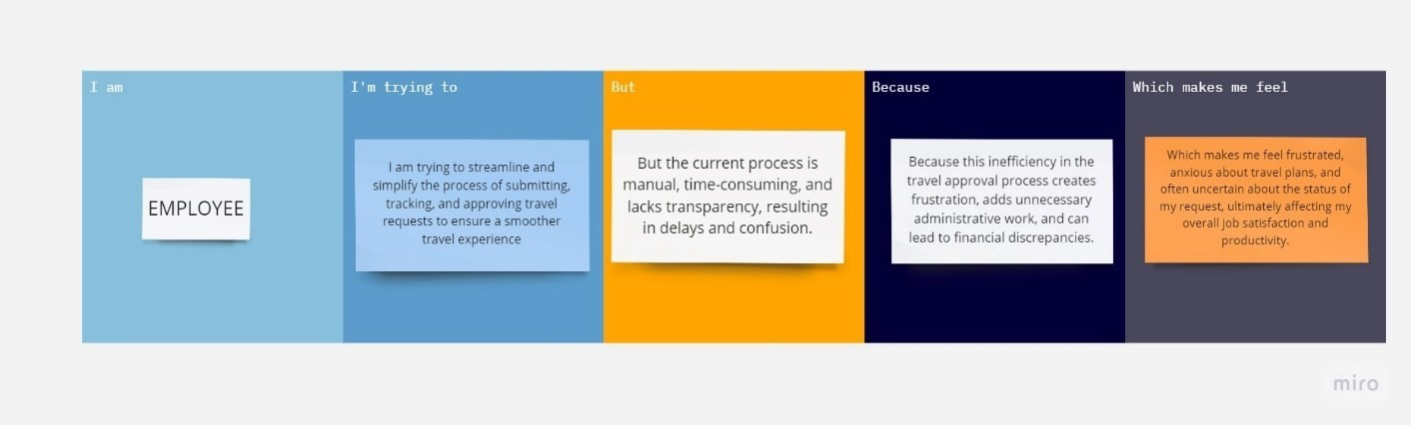

|  |  |  |  |  |  |
| --- | --- | --- | --- | --- | --- |
| **Problem Statement (PS)** | **I am (Employee)** | **I’m trying to** | **But** | **Because** | **Which makes me feel** |
| PS | Student | I am trying to manage the students, teachears record for the short period in the way of application. | But the current process is manual, time- consuming, and lacks transparency  , resulting in delays and confusion. | Because this inefficiency way to find and track the students and teachers through the application. | Which makes me feel frustrated, anxious often uncertain about the status of my request, ultimately affecting my overall job satisfaction and productivity |

* 1. **Empathy Map Canvas**

An empathy map is a simple, easy-to-digest visual that captures knowledge about a

user’s behavior and attitudes.

It is a useful tool to helps teams better understand their users. Creating an effective solution requires understanding the true problem and the person who is experiencing it. The exercise of creating the map helps participants consider things from the user’s perspective along with his or her goals and challenges.

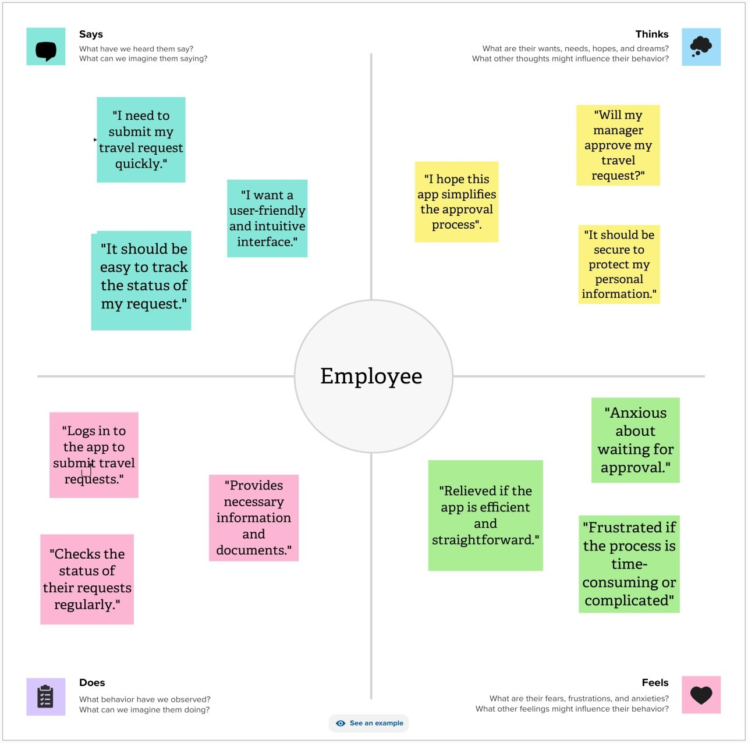

SCHOOL

# Ideation & Brainstorming

Brainstorming provides a free and open environment that encourages everyone within a team to participate in the creative thinking process that leads to problem solving.

Prioritizing volume over value, out-of-the-box ideas are welcome and built upon, and all participants are encouraged to collaborate, helping each other develop a rich amount of creative solutions.

## Step-1: Team Gathering, Collaboration and Select the Problem Statement:

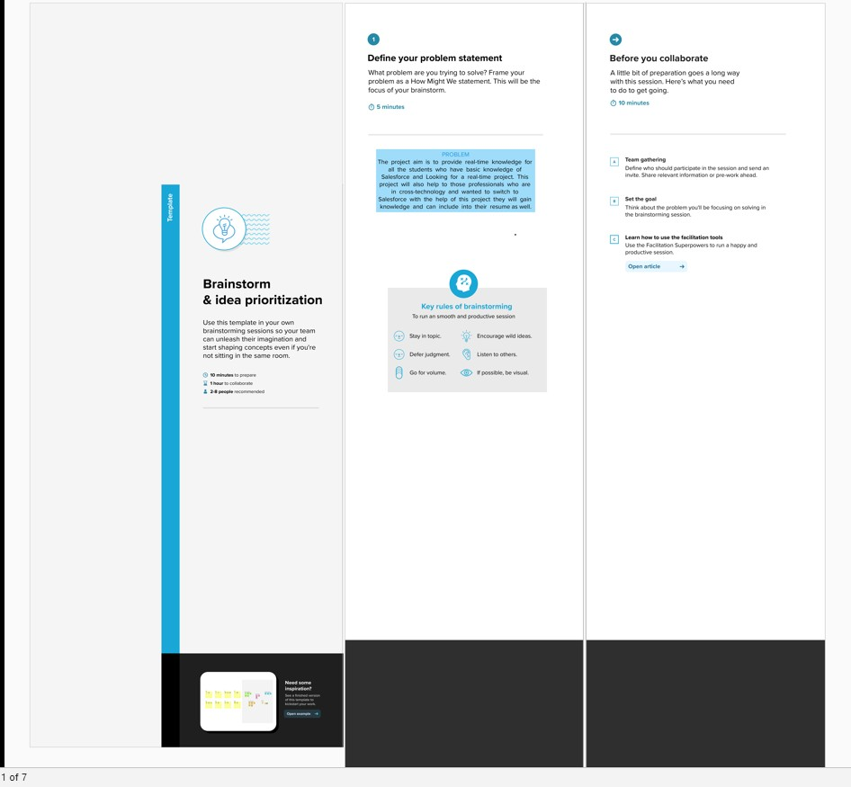

**Step-2: Brainstorm, Idea Listing and Grouping:**

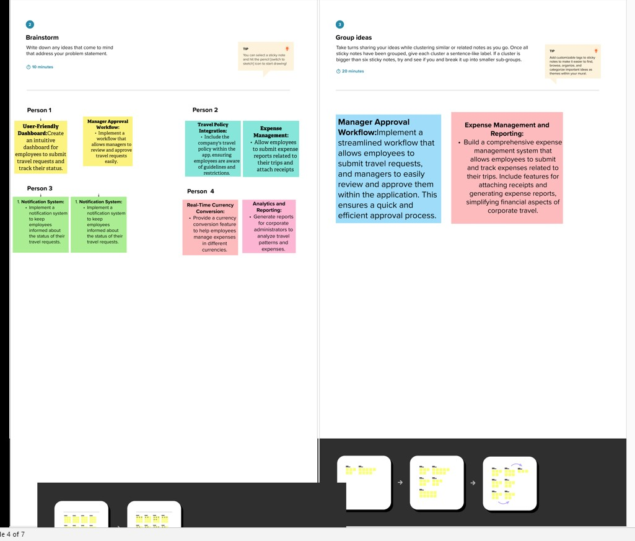

**Step-3: Idea Prioritization:**

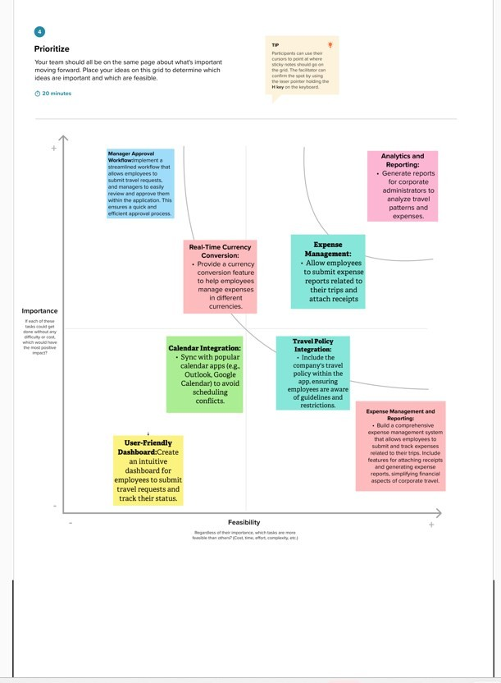

# Proposed Solution

|  |  |  |
| --- | --- | --- |
| **S. No** | **Parameter** | **Description** |
| 1. | Problem Statement (Problem to be solved) | Corporates often grapple with inefficient and manual travel approval processes that involve paperwork and a lack of transparency. These outdated methods lead to delays, increased administrative work, and potential compliance issues. The process is a source of stress for employees who require timely approvals to plan their business trips effectively, and it leaves them dissatisfied with the process.  Managers, on the other hand, struggle to review and manage a high volume of travel requests while ensuring compliance. The absence of transparency leads to bottlenecks and a lack of visibility, leaving them  overwhelmed and frustrated. |
| 2. | Idea / Solution description | Our proposed solution is to develop an  School Management application within Salesforce, offering automation and centralization. The application will provide a user-friendly and automated system that allows teachers to submit student requests seamlessly. Organizations will be able to review and approve them efficiently, while the system offers real-time tracking of request statuses. It will also include integration with external systems for expense management, robust security measures, mobile accessibility and analytics tools for data-driven decision- making. The benefits include reduced administrative burdens, improved communication, cost control, and better compliance with corporate policies and  regulations. |

|  |  |  |
| --- | --- | --- |
| 3. | Novelty / Uniqueness | What sets our solution apart is the innovative use of Salesforce, a highly customizable and powerful platform, to streamline corporate travel management. The automation of approval workflows and integration with external systems will significantly reduce manual work and errors. The mobile app component will provide users with the flexibility and convenience of on-the-go access. Furthermore, the incorporation of robust reporting and analytics tools will enable data-driven decision-making and offer insights into travel expenses, setting our  solution apart from conventional methods. |
| 4. | Social Impact / Customer Satisfaction | Our application will have a substantial social impact by enhancing the user experience in corporate travel management. Employees and managers will benefit from a smoother, more transparent, and efficient travel approval process, reducing frustration and uncertainty. The streamlined process will free up time and resources for more strategic tasks, thereby improving overall workforce productivity.  Data-driven decision-making will lead to better cost management, making it easier to control expenses and ensuring financial compliance. The application will also guarantee compliance with corporate policies and regulatory requirements, reducing risks and ensuring data security. Lastly, by optimizing travel planning, our solution can contribute to a more sustainable approach to business travel, aligning with corporate  sustainability goals. |

* 1. **Functional & Technical Requirements**

## Functional Requirements

|  |  |  |
| --- | --- | --- |
| **FR**  **No.** | **Functional Requirement**  **(Epic)** | **Sub Requirement (Story / Sub-Task)** |
| FR-1 | User Management | **User Registration:** Allow employees to register and log into the system.  **User Roles:** Define roles (employees, managers, travel administrators) with different permissions. **User Profiles:** Capture and manage user profiles,  including contact details. |
| FR-2 | Travel Request Submission | **Student Request Form:** Provide an intuitive form for employees to submit travel requests.  **Expense Entry:** Allow users to enter estimated expenses, including flights, accommodation, meals, and incidentals.  **Dates:** Specify departure and return dates, including the option for flexible schedules.  **Attachments:** Enable the attachment of supporting documents, such as itineraries or conference detail |
| FR-3 | Approval workflow | **Workflow Automation:** Implement an automated approval process with defined workflows.  **Manager Assignment:** Automatically route requests to the appropriate manager based on criteria like department or project.  **Notifications:** Send notifications to managers and employees at various stages of the approval process. **Delegation**: Allow managers to delegate their  approval authority when they are unavailable. |
| FR-4 | Approval Management | **Manager Dashboard**: Provide managers with a dashboard to view and manage pending travel requests.  **Request Review:** Allow managers to review travel details, expense estimates, and supporting documents.  **Approval/Rejection:** Enable managers to approve or reject requests with comments.  **Escalation:** Implement escalation processes for  unattended requests or those exceeding certain thresholds |

|  |  |  |  |
| --- | --- | --- | --- |
| FR-5 | Expense Tracking | **Expense Tracking:** Record actual expenses incurred during the trip.  **Receipt Upload:** Allow users to upload expense receipts for verification.  **Expense Categories:** Categorize expenses (e.g., transportation, lodging, meals) for reporting.  **Expense Reconciliation:** Compare estimated and  actual expenses for cost control. |  |
| FR-6 | Reporting and Analytics | **Reporting Tools:** Develop custom reports and dashboards to monitor travel request status and expenses.  **Analytics:** Implement data analytics for insights into travel patterns, expenses, and approval efficiency.  **Export:** Allow users to export reports for offline  use or sharing | |

* + 1. **Technical Requirements**

|  |  |  |
| --- | --- | --- |
| **TR**  **No.** | **Technical Requirement** | **Description** |
| TR-1 | Salesforce Environment | Utilize Salesforce's Enterprise or Unlimited edition to ensure scalability and access to  advanced features. |
| TR-2 | Development language | Develop using Salesforce's proprietary  programming language, Apex, for server- side logic. |
| TR-3 | Security | * Implement role-based access control (RBAC) to control who can access and modify data. * Encrypt sensitive data both in transit and at rest. * Utilize Salesforce Shield for enhanced security, including event monitoring and   field-level encryption. |
| TR-4 | Integration | * Use REST and SOAP APIs for integration with external systems, such as finance and expense management tools. * Implement Single Sign-On (SSO)   solutions for seamless and secure access. |
| TR-5 | Customization | Allow administrators to customize and configure the application, including approval workflows,  fields, and user profiles. |
| TR-6 | Mobile Accessibility | * Ensure that the application is accessible via the Salesforce mobile app for on-the- go request submission and tracking. * Develop a custom mobile app using Salesforce Mobile SDK for more tailored   mobile functionality. |

# Project Road Map

## Data Flow Diagram

A Data Flow Diagram (DFD) is a traditional visual representation of the information flows within a system. A neat and clear DFD can depict the right amount of the system requirement graphically. It shows how data enters and leaves the system, what changes the information, and where data is stored.

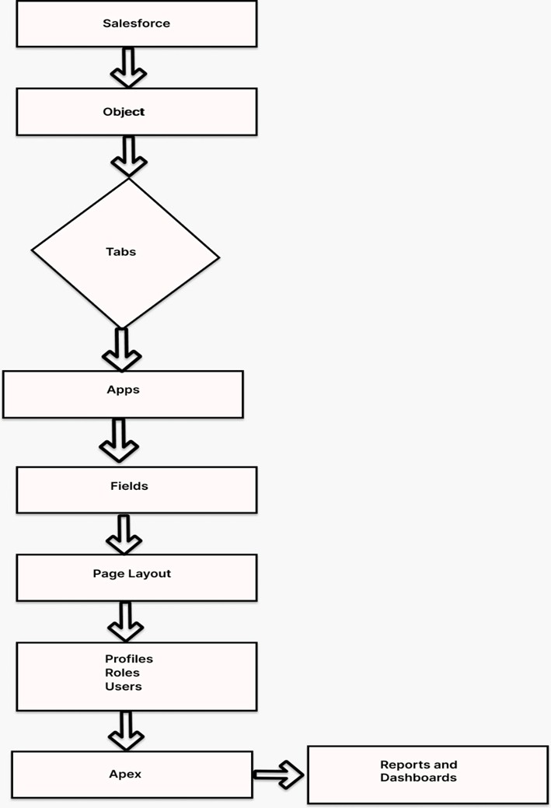

## Technical Archictecture

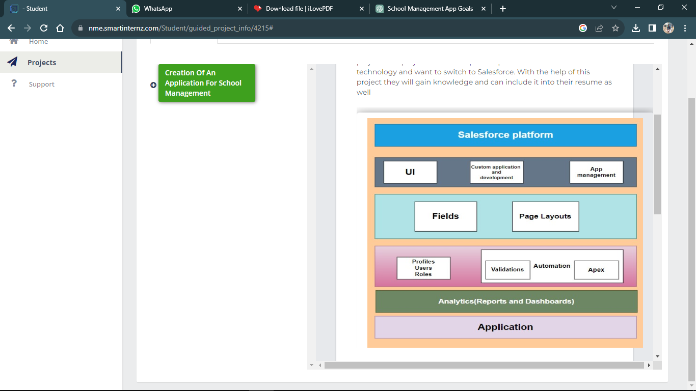

**TABLE-1: Component and Technologies:**

|  |  |  |  |
| --- | --- | --- | --- |
| **S.No** | **Component** | **Description** | **Technology** |
| 1. | User Interface | **Lightning Components**: Use Salesforce Lightning components to design the user interface for employees, managers, and administrators.  **Custom Pages:** Create custom Visualforce  pages for more tailored and complex UI elements | Salesforce |
| 2**.** | Data Model | **Custom Objects:** Define custom objects in Salesforce to represent entities like travel requests, expenses, and approvals. **Master-Detail and Lookup Relationships:** Establish relationships between objects to maintain data integrity.  Custom Fields: Create custom fields to capture specific information, such as parents, students, and teachers. | Salesforce |

|  |  |  |  |
| --- | --- | --- | --- |
| 3. | Workflow Automation | **Approval Processes:** Implement Salesforce Approval Processes to automate and streamline the travel request approval workflow.  **Process Builder and Flows:** Use Process Builder and Flows to automate routine  tasks and send notifications. | Salesforce |
| 4. | Reporting and Analytics | **Custom Reports:** Create custom reports to track travel request status,  expenses, and other relevant metrics. | Salesforce |
| 5. | Security | **Role-Based Access Control (RBAC):** Configure RBAC to control who can access and modify data.  **Data Encryption:** Encrypt sensitive data both in transit and at rest.  **Audit Trails:** Maintain audit trails to log user activities for security and compliance  purposes. | Salesforce |
| 6. | Salesforce Development | **Apex:** Use Salesforce's proprietary programming language, Apex, for server-side logic and data manipulation.  **Visualforce:** Develop custom user interfaces with Visualforce pages and components.  **Lightning Web Components:** Create modern, component-based UIs using Lightning Web Components for a more responsive and dynamic  user experience | Salesforce |

**Table-2: Application Characteristics:**

|  |  |  |  |
| --- | --- | --- | --- |
| **S. No** | **Characteristics** | **Description** | **Technology** |
| 1. | Responsive Design | Implement responsive design to adapt to various screen sizes, ensuring a consistent and visually pleasing user  experience. | salesforce |
| 2**.** | Accessibility | Ensure that the application is accessible via multiple devices and browsers, catering to users on desktops, tablets, and mobile devices. This accessibility is crucial for users who need to make or approve travel  requests while on the go. | salesforce |
| 3. | User- friendly | The application should have an intuitive and user-friendly interface to make it easy for employees, managers, and administrators to navigate and use  the system without extensive training. | Salesforce |
| 4. | Scalability | The application should be able to scale with the growing number of users and data, accommodating increasing demands without  significant performance degradation. | salesforce |
| 5. | Performance | Ensure the application's performance meets or exceeds user expectations, with rapid response times for actions such as submitting requests or generating reports. | salesforce |
| 6. | Reporting and Analytics | Enable users to generate custom reports and access analytics tools to gain insights into travel patterns, expenses, and approval efficiency. | salesforce |

# CHAPTER-2 PREPARATION DATA MODELING

* 1. **Salesforce Developer Org**

In Salesforce, a Developer Sign Up or Developer Edition is a special type of Salesforce environment that is primarily used for development, testing, and learning purposes.

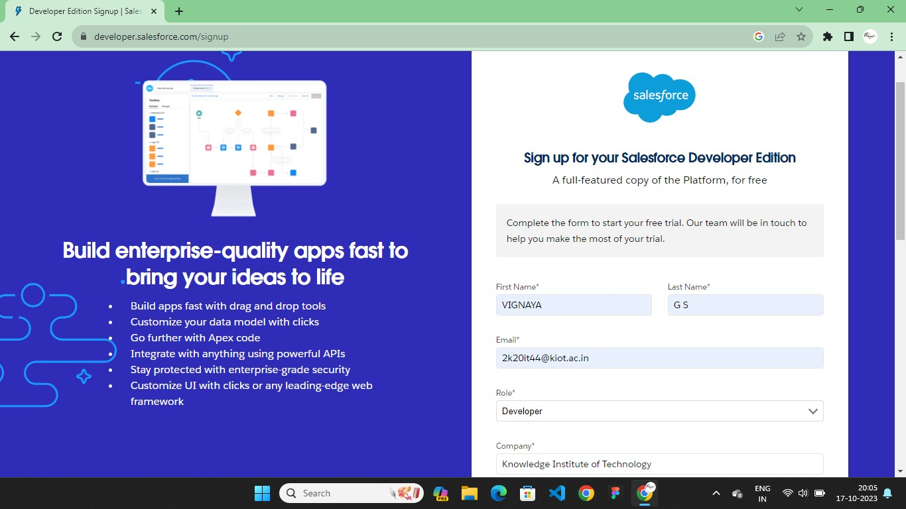

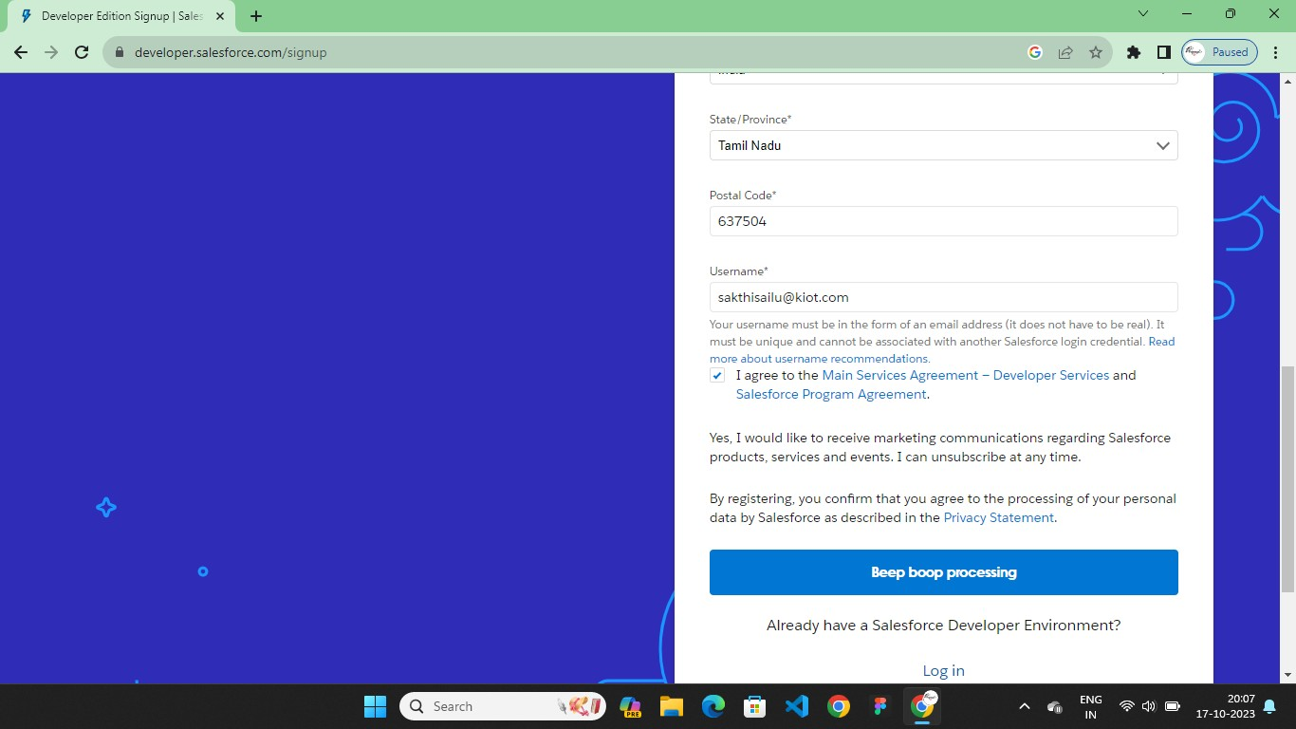

# Account Activation

Activation tracks information about devices from which users have verified their identity.

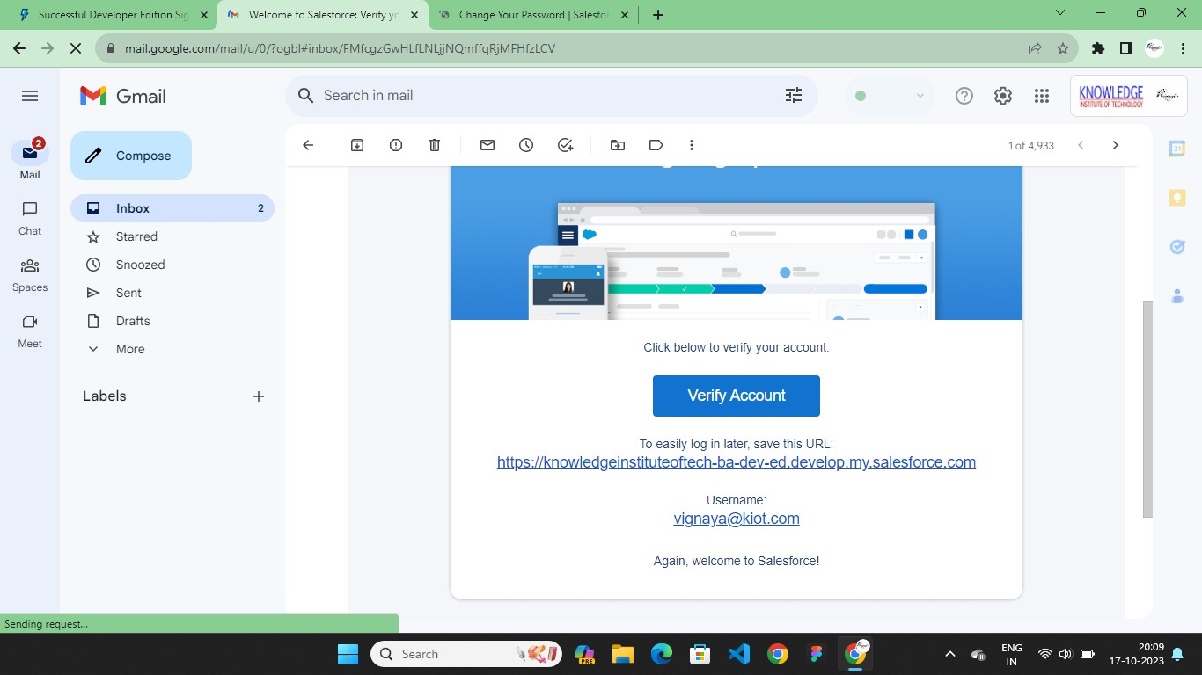

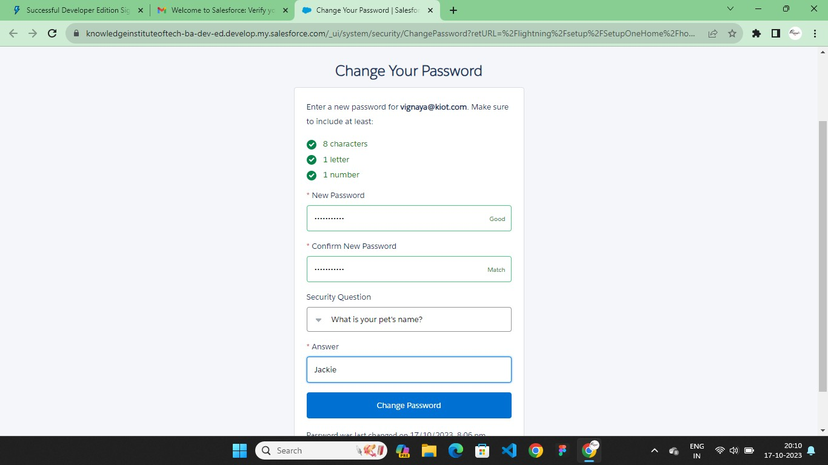

# Custom Object Creation & Tabs

**Custom Object Creation**

Objects are containers for your information, but they also give you special functionality.

Custom objects are create to store information that’s specific to your company or industry. Custom Objects in Travel Approval App:

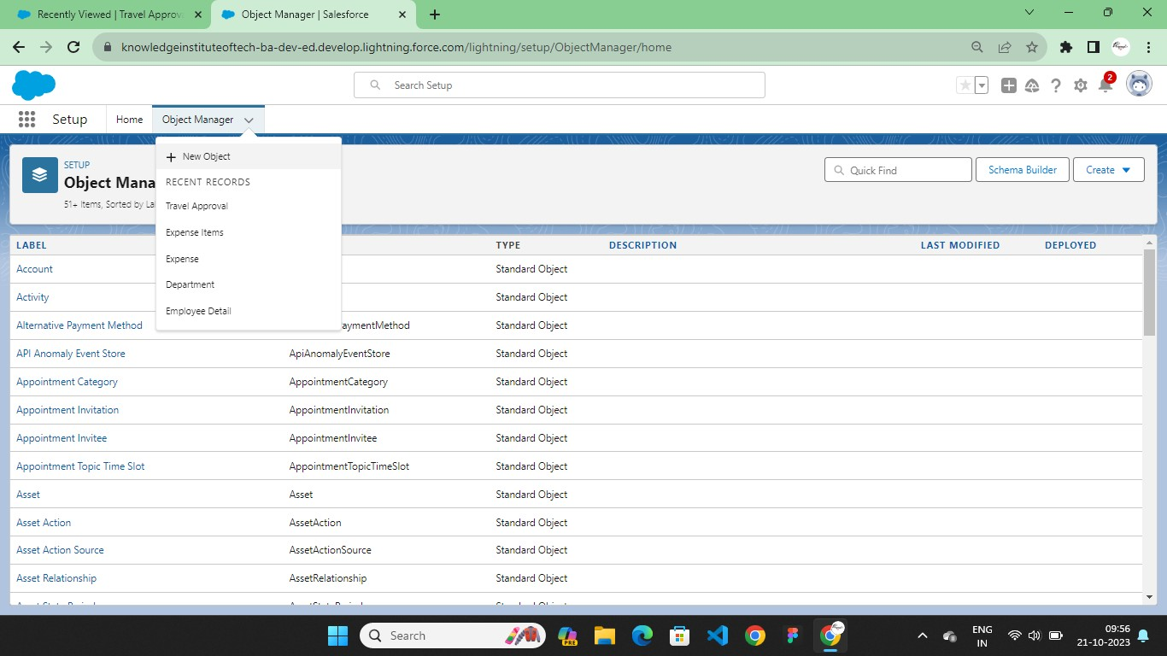

## Fields in School Object

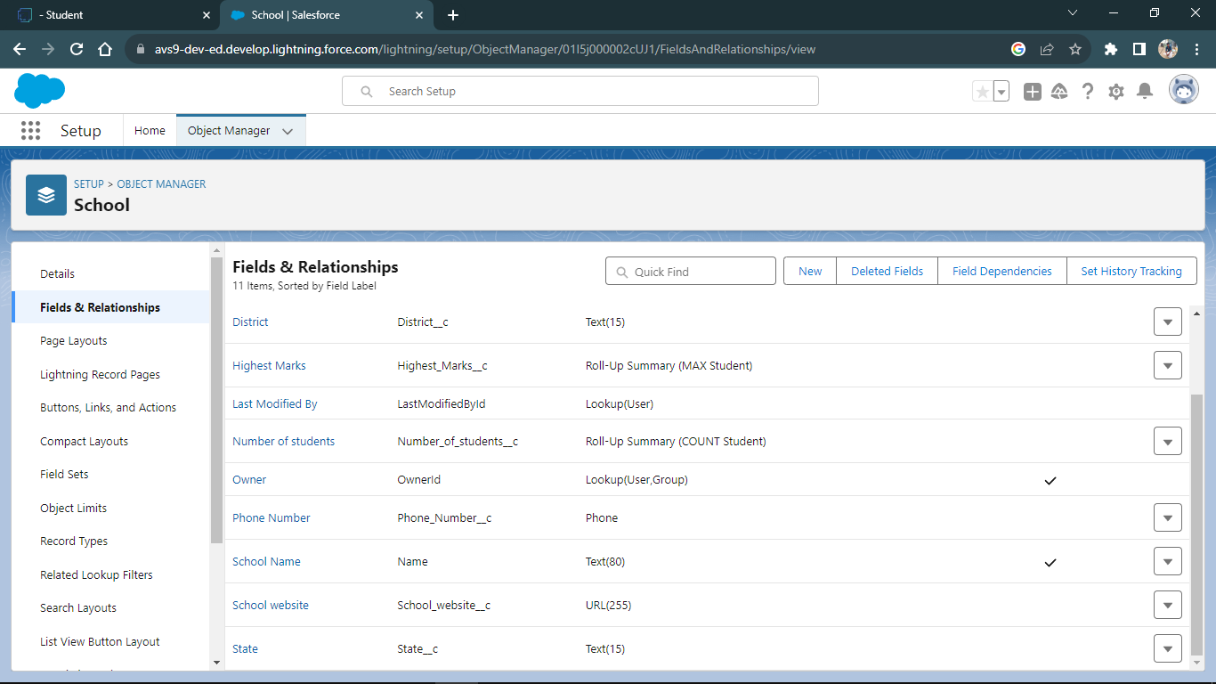

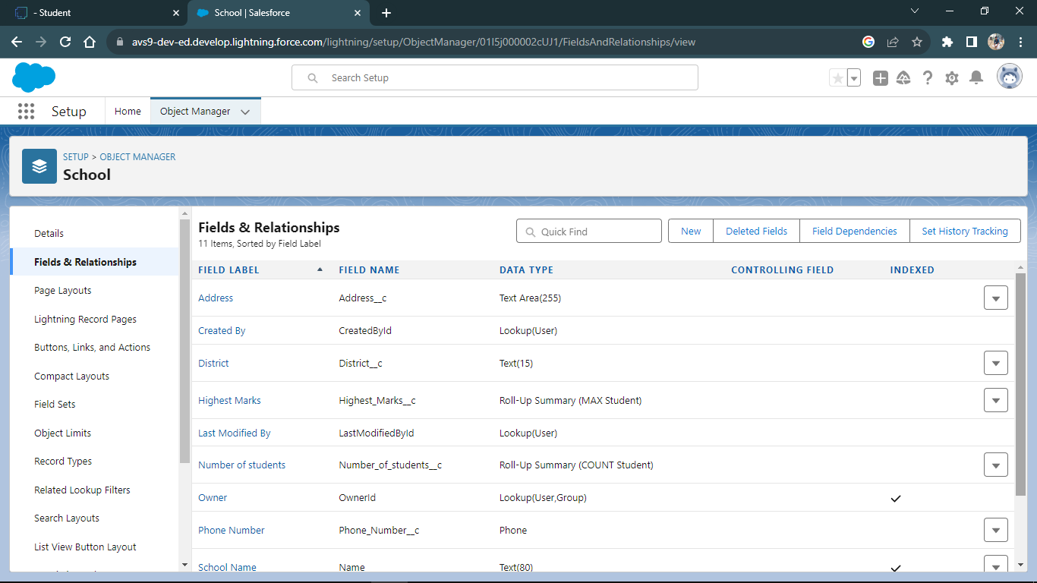

**Fields in Student Object**

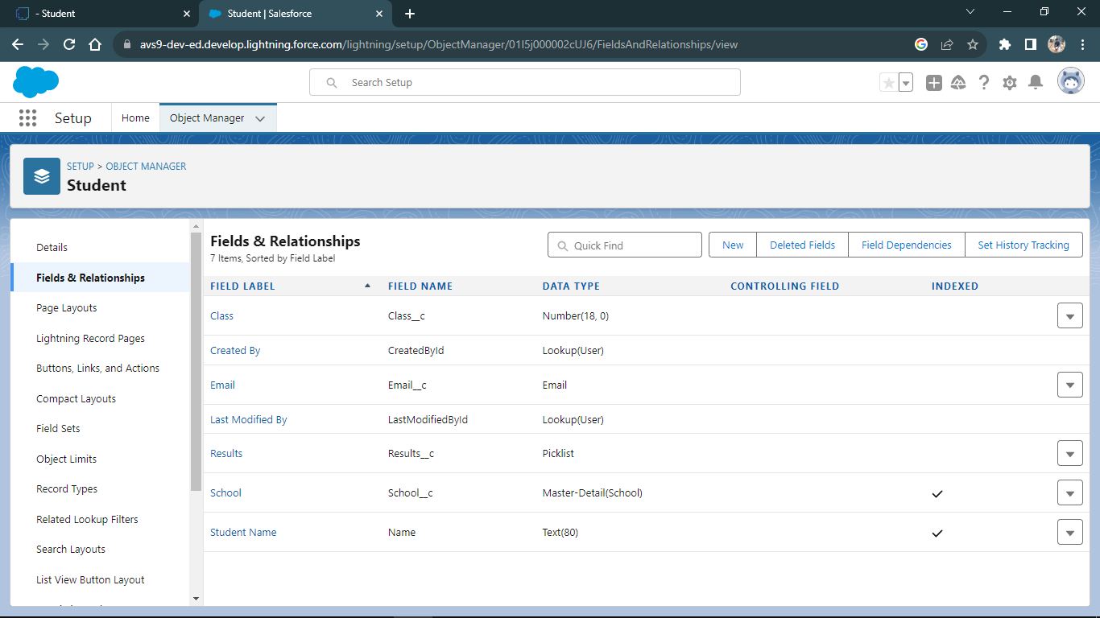

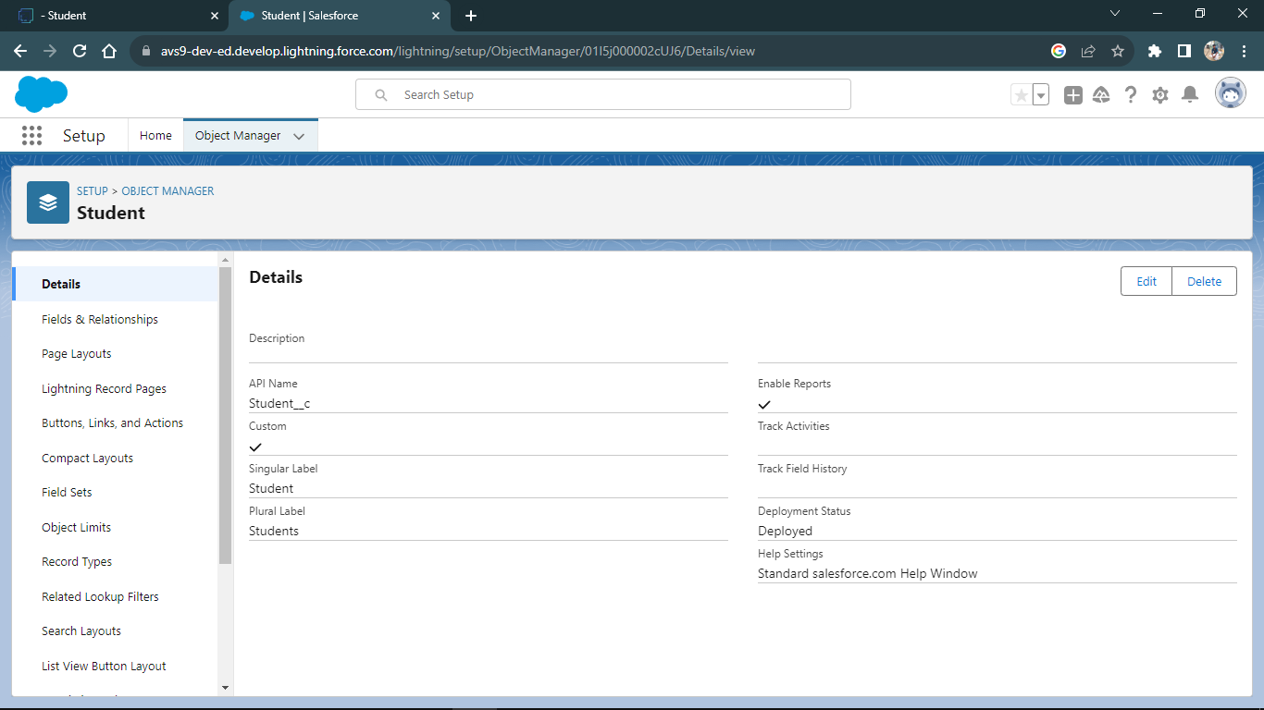

## Fields in Parent Object

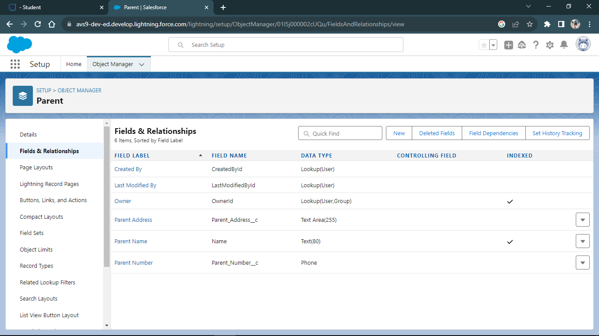

## Tabs

Salesforce Tabs are like the menu options in a software application. They allow you to access specific functions, objects, or data.

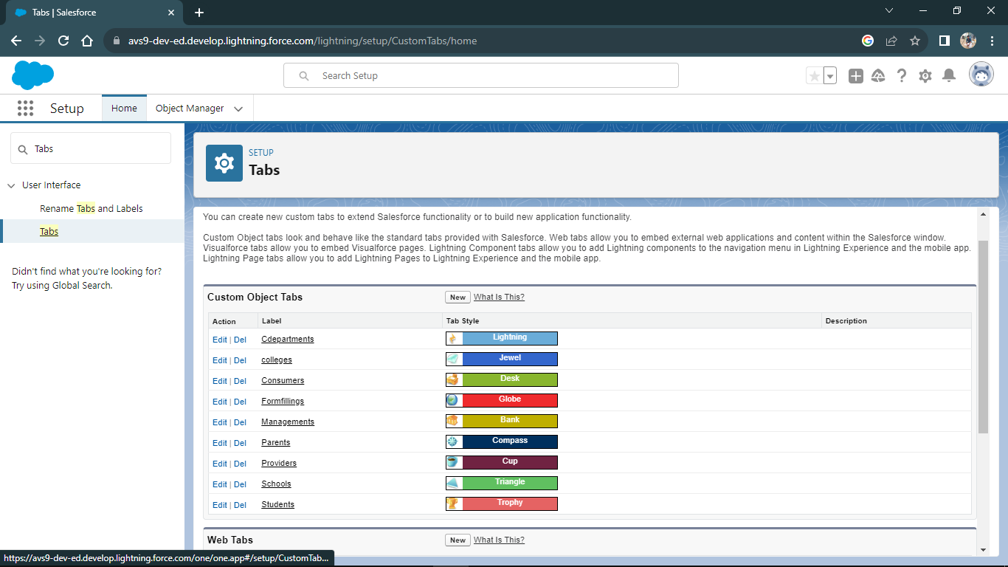

# Lightning App

The Lightning App Builder is a point-and-click tool that makes it easy to create custom pages for the Salesforce mobile app and Lightning Experience, giving your users what they need all in one place.

Create a School Management Lightning App

* + - Build a Lightning app, add tabs, and customize page layouts.
    - Create custom objects and fields for the app.
    - Define relationships between objects.

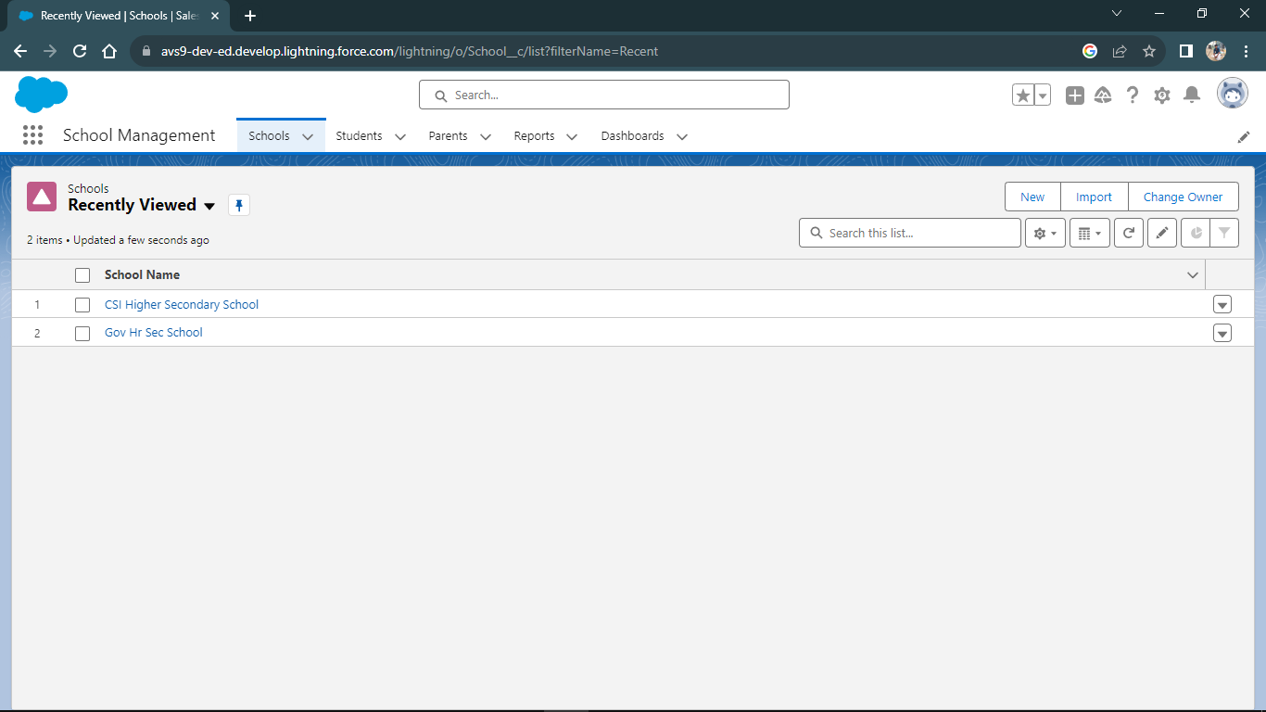

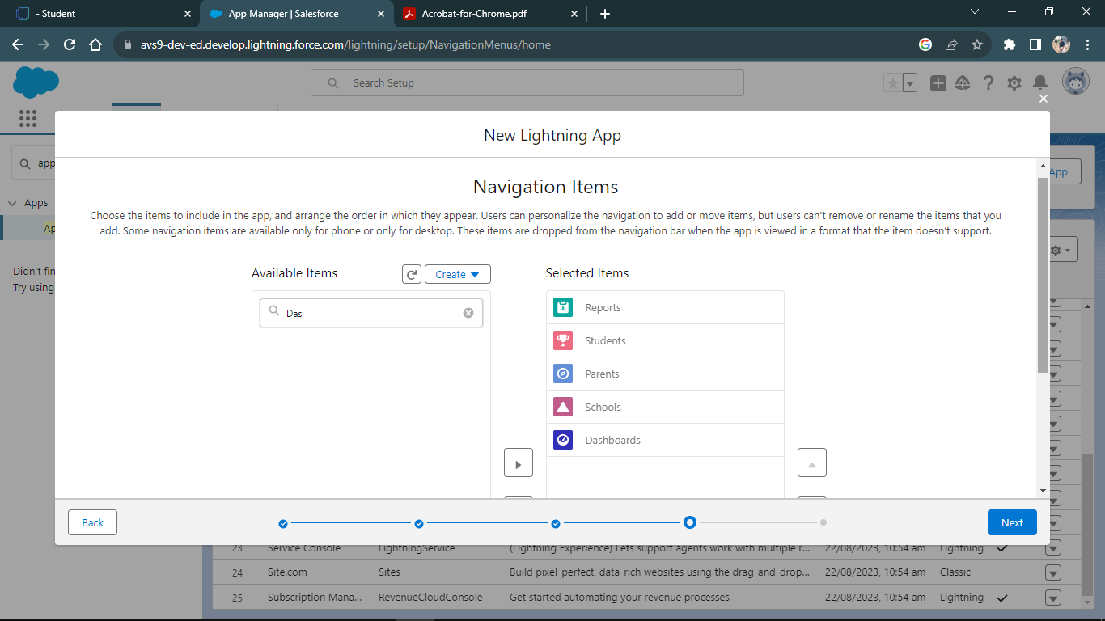

# Relationship between Objects

## Master-Detail Relationship

A master-detail relationship defines the relationship between the parent and the child.

The master table defines the parent relation and the detail defines the child relation.

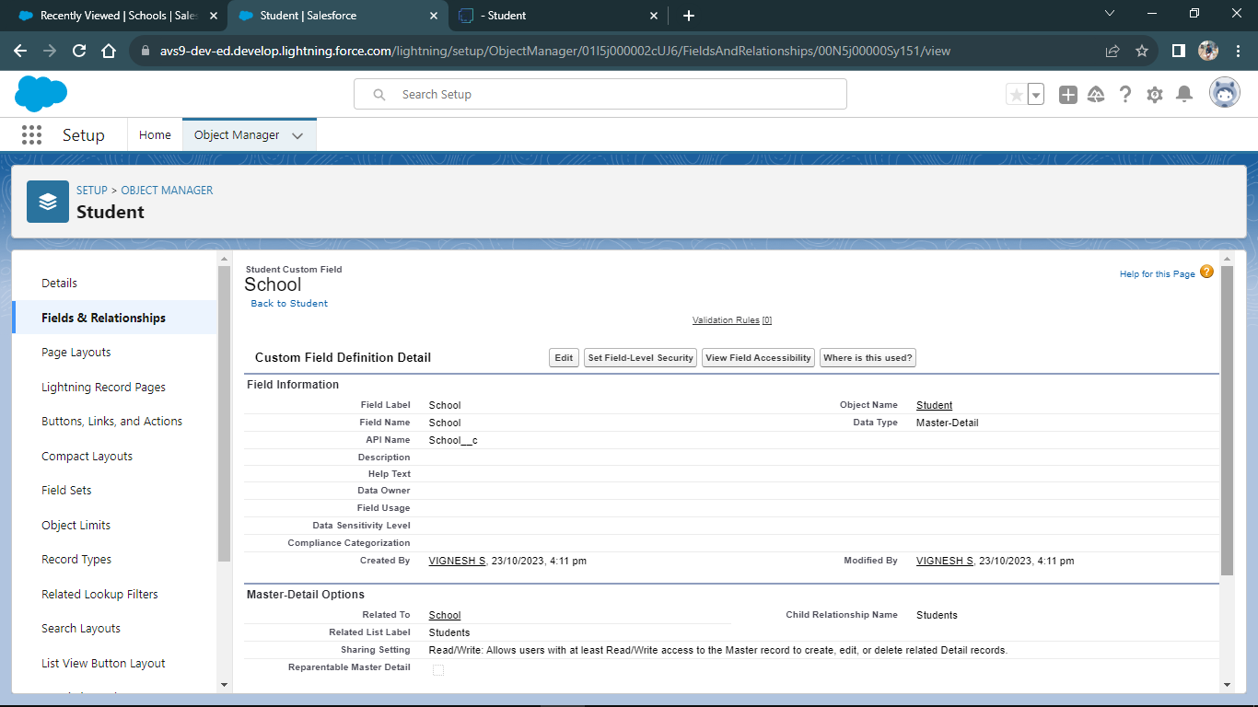

## Roll-up Summary

Roll-Up Summary Fields in Salesforce summarize data of particular fields from a set of related detail records and automatically display the output on the master record.

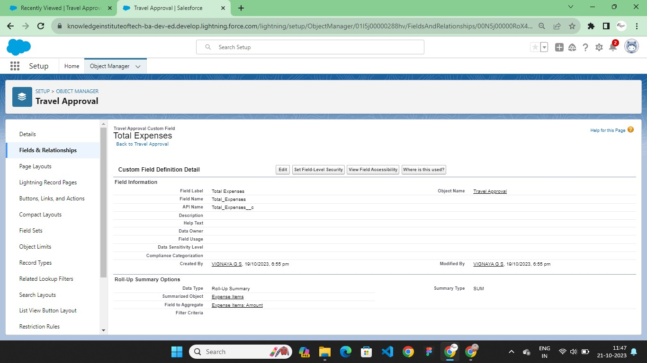

# CHAPTER-3

**USERS & DATA SECURITY**

# 3.1 User Creation & Setup Approvals

Before customizing the travel app, first create a new user, Eric Executive, and set him up as manager. This involves assigning roles and profiles so that Eric has the correct permissions to approve travel requests.

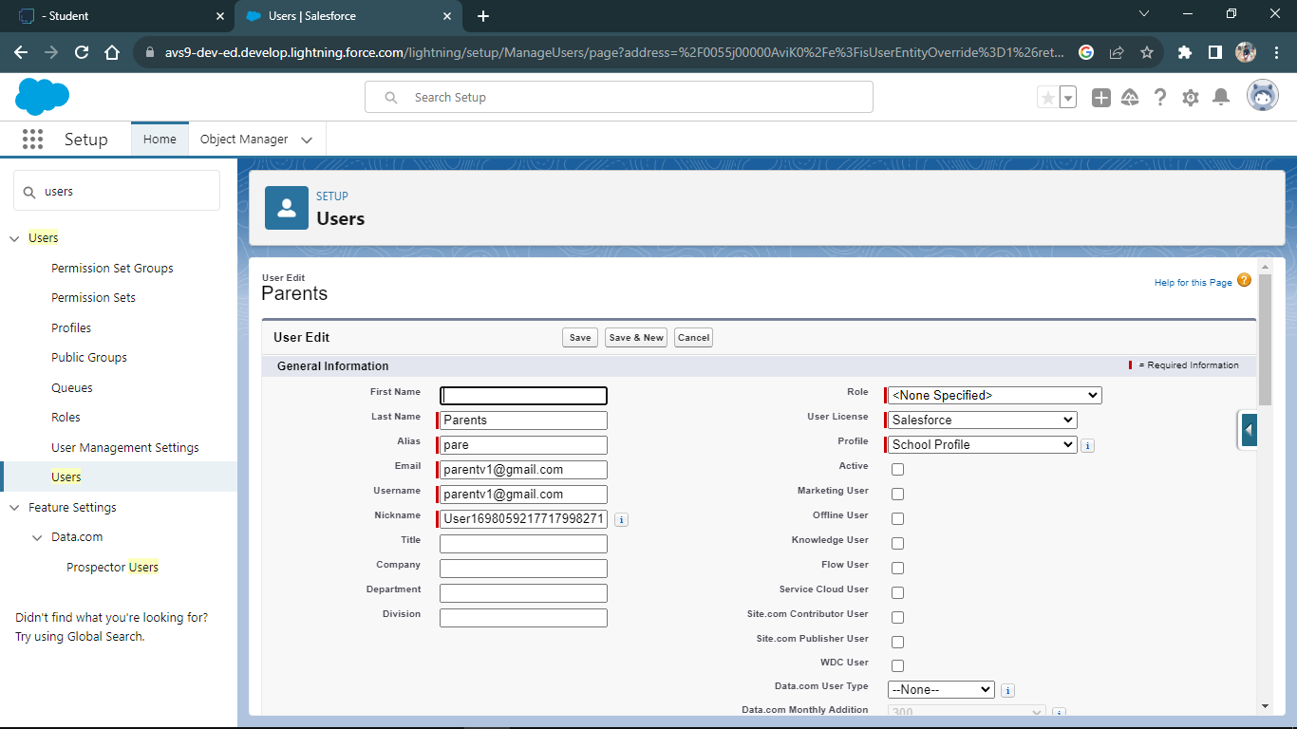

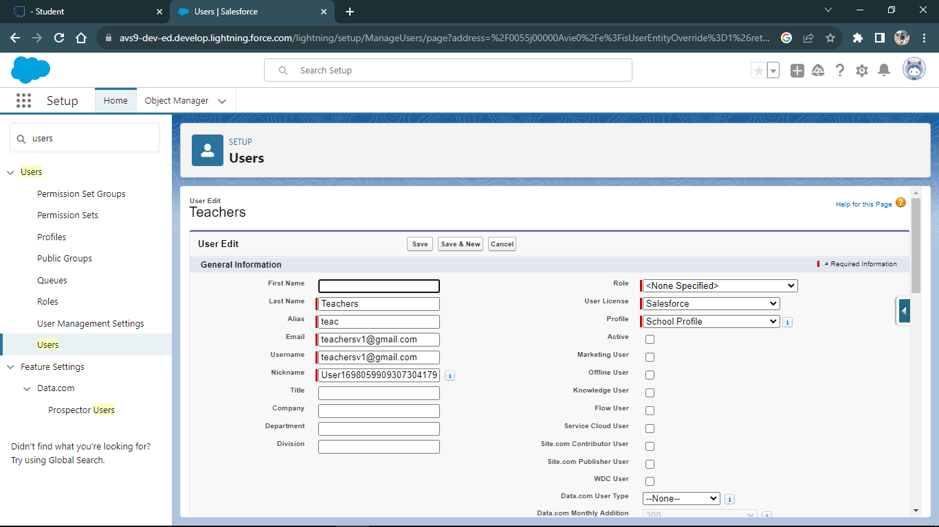

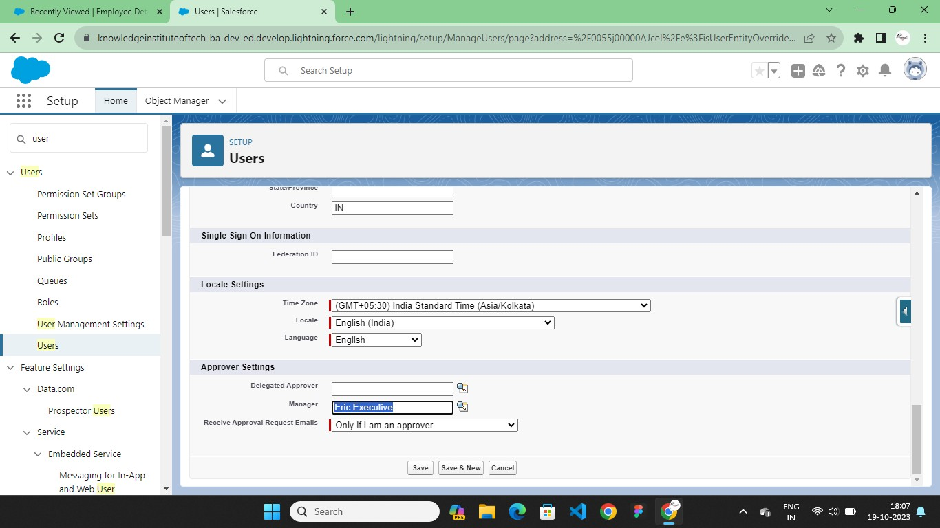

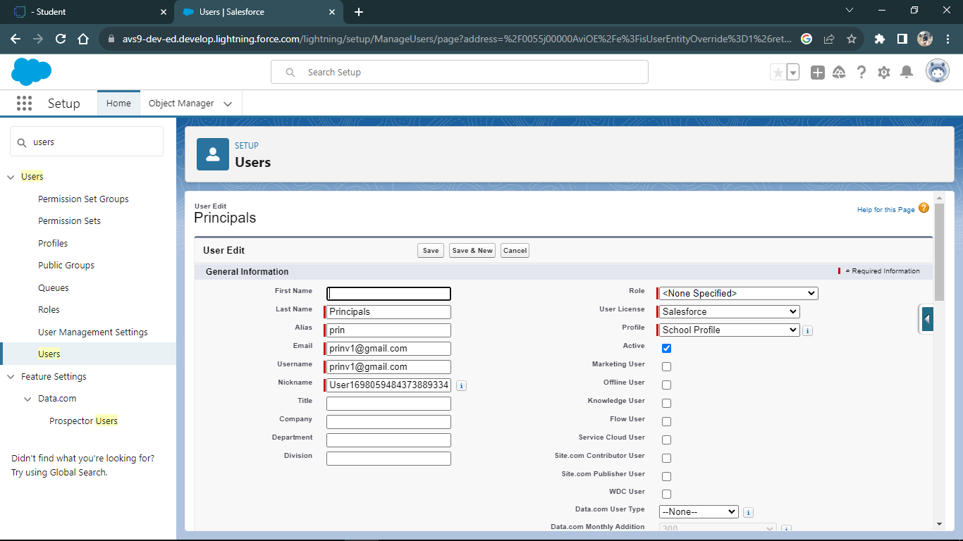

# CHAPTER-4 AUTOMATION

* 1. **Flow**

The last business rule functionality to implement before testing your application is a rule to set the Out-of-State checkbox field on the Travel Approval object if out-of-state travel has been chosen. Salesforce offers workflow capabilities that provide a declarative, drag-and- drop design environment to build our business process logic.

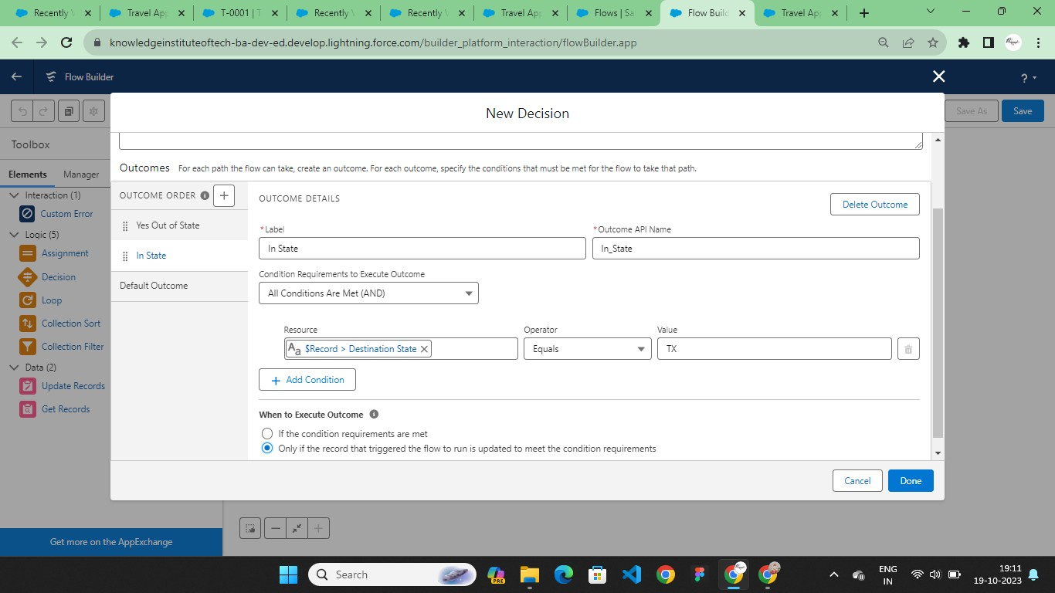

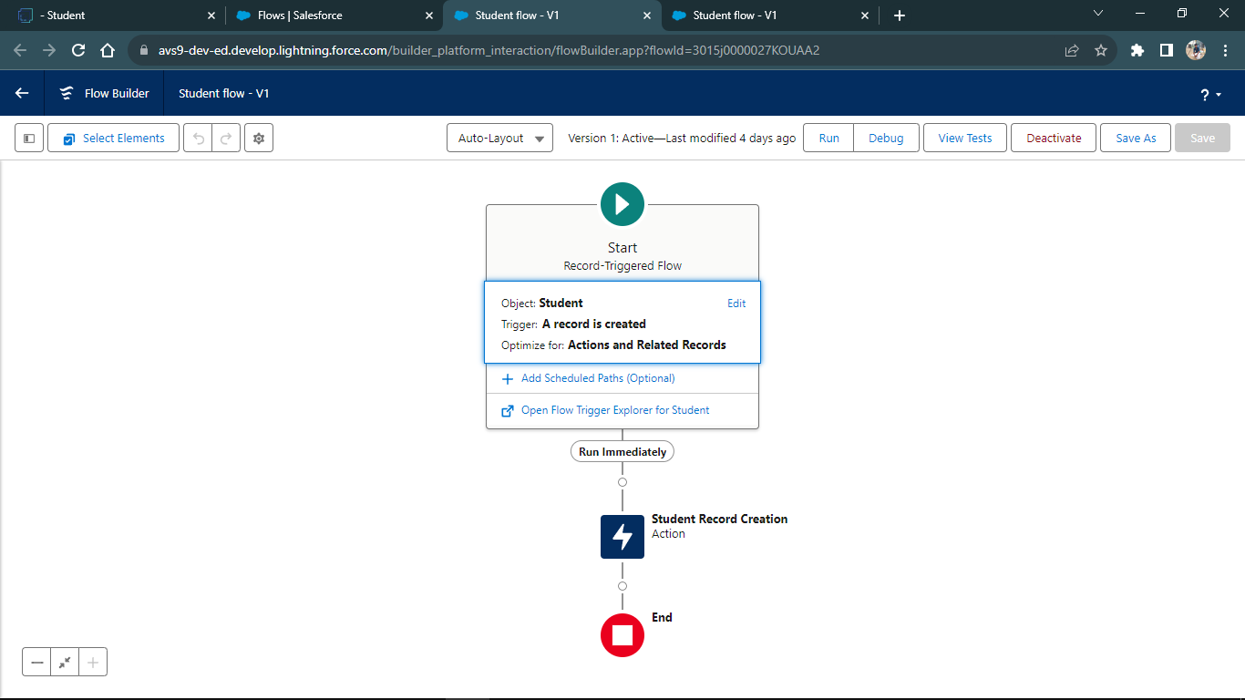

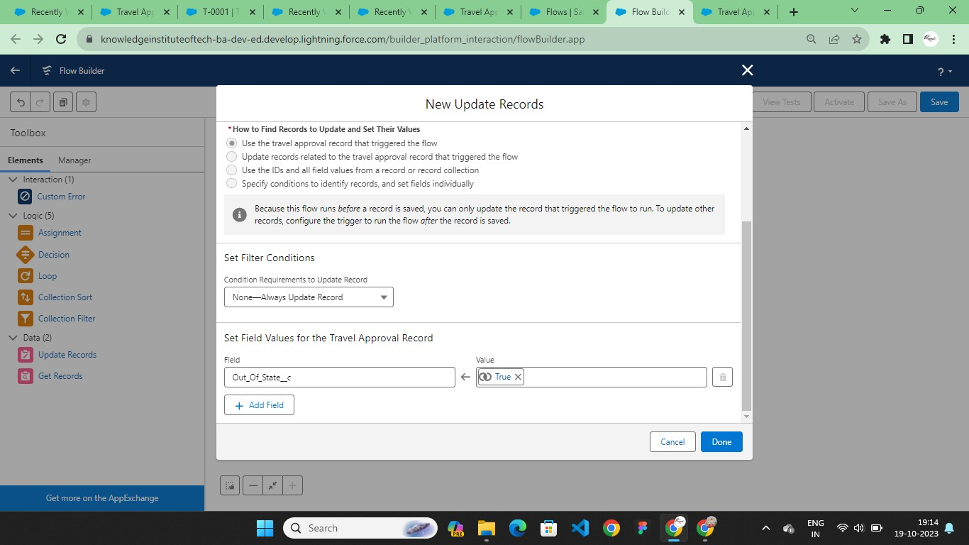

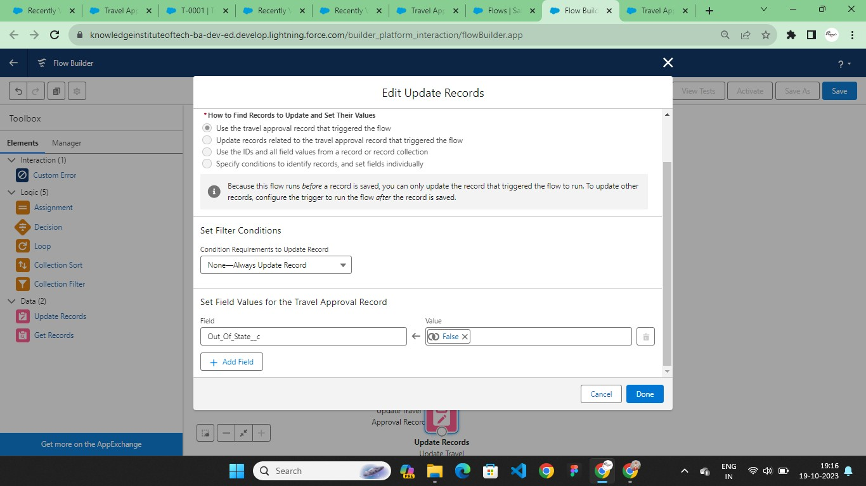

# Final Views

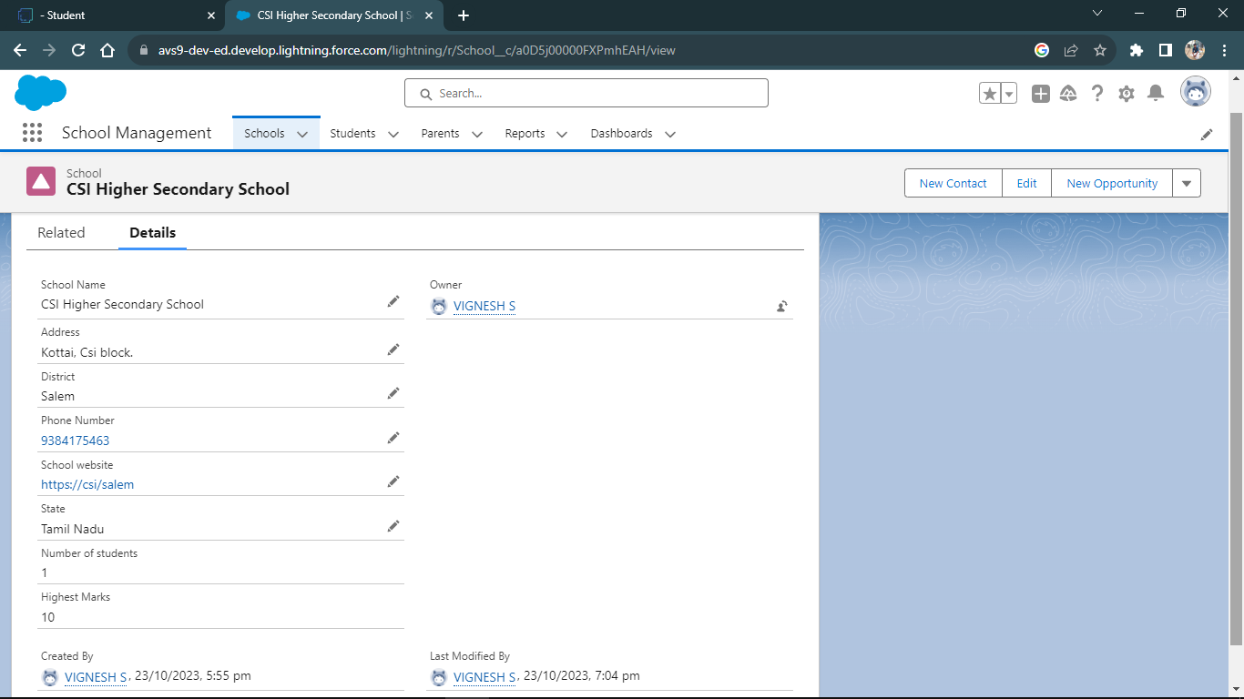

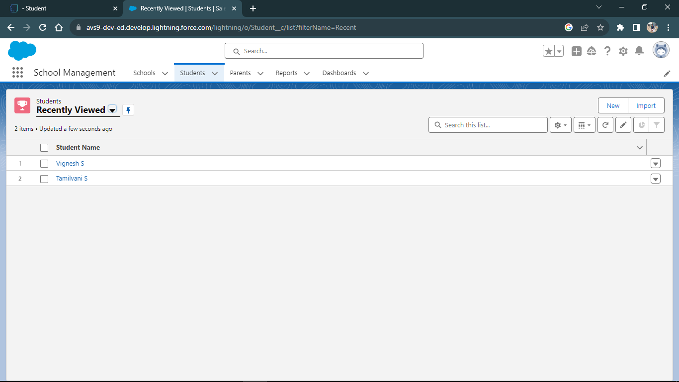

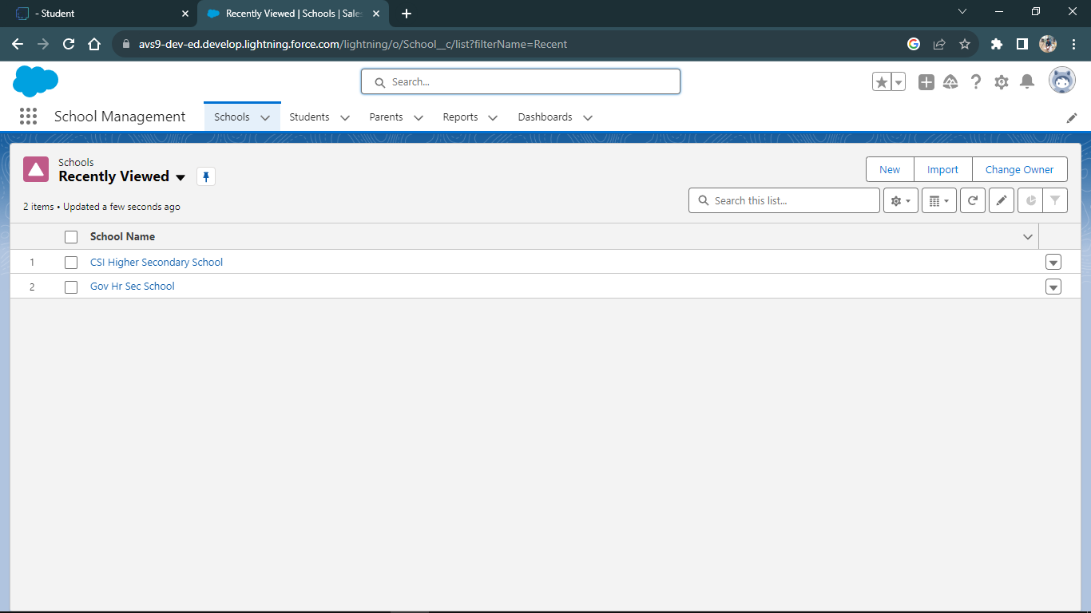

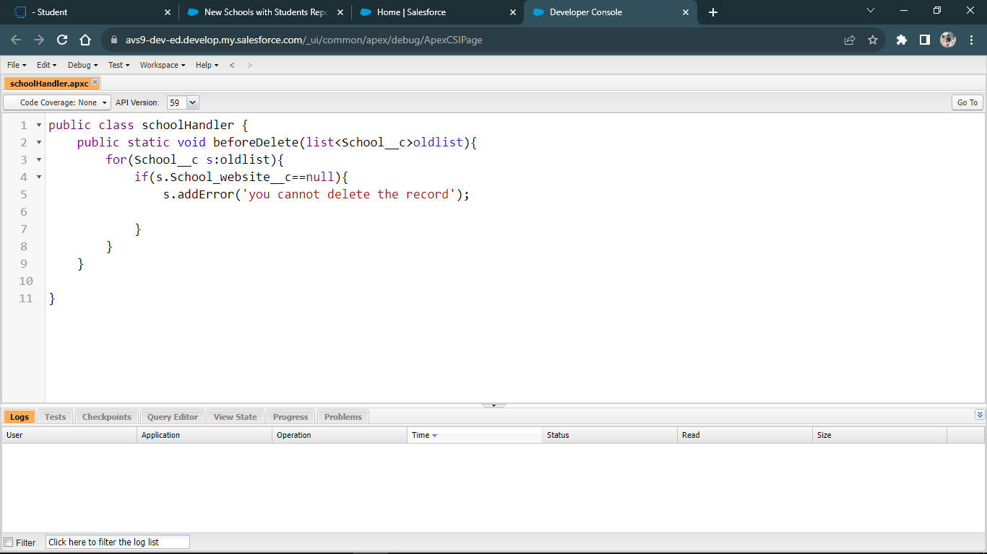

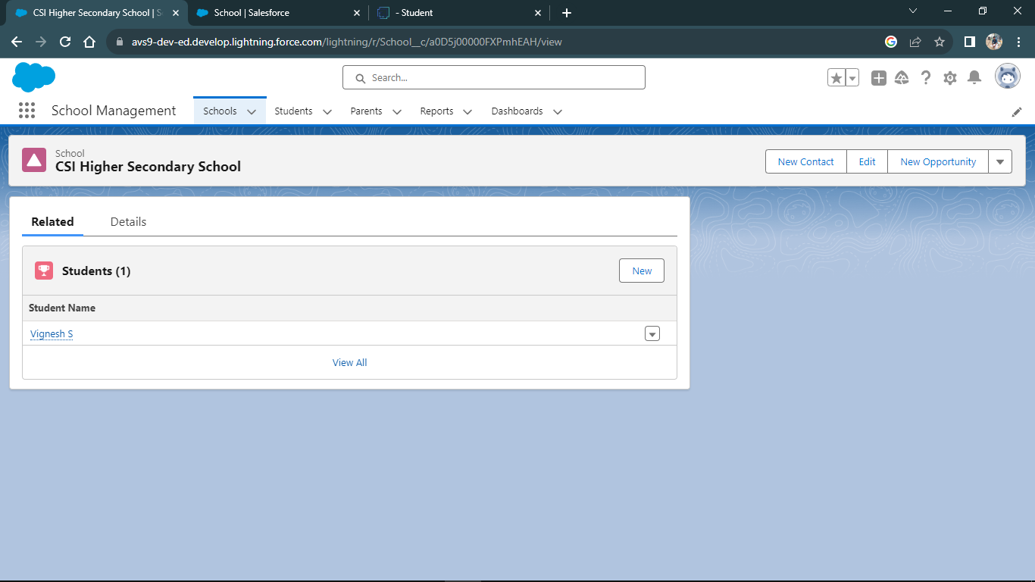

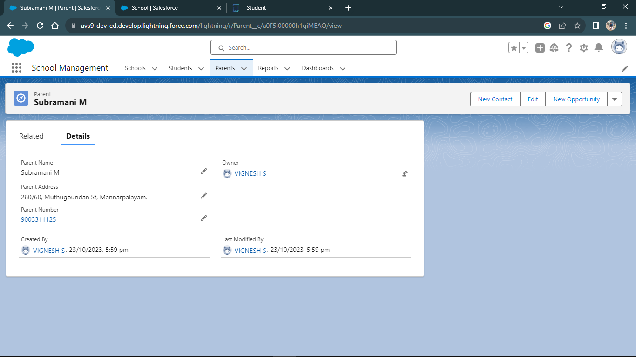

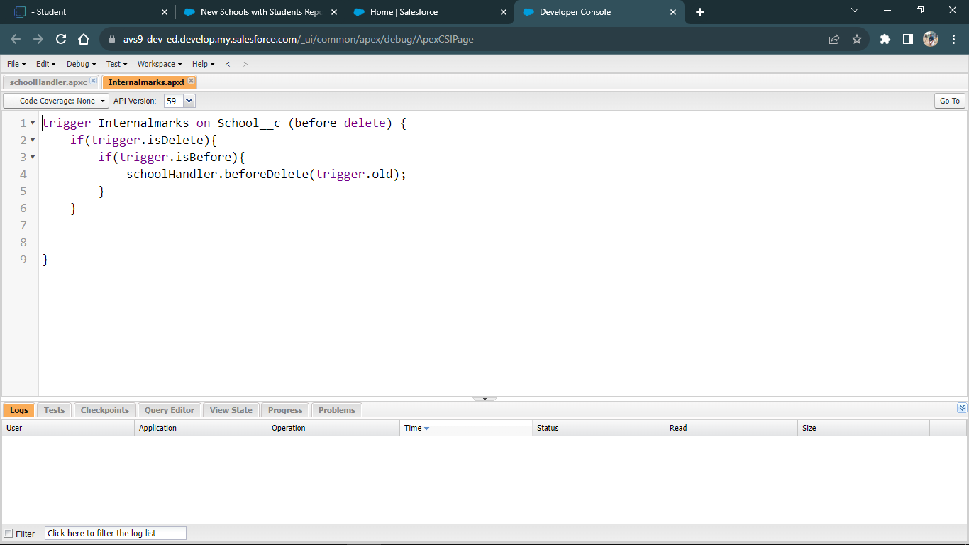

**CHAPTER-4 REPORTS & DASHBOARD**

# 4.1Reports

A Salesforce report is a list of data generated based on filter criteria. Salesforce Reports helped us predict trends and gives us the advantage to increase profits.

The report builder provides a drag-and-drop interface to easily build and customize your reports.

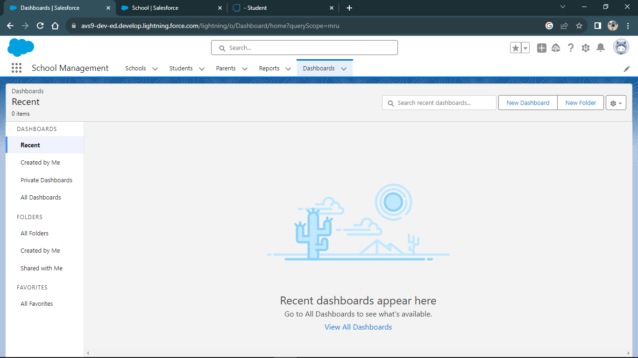

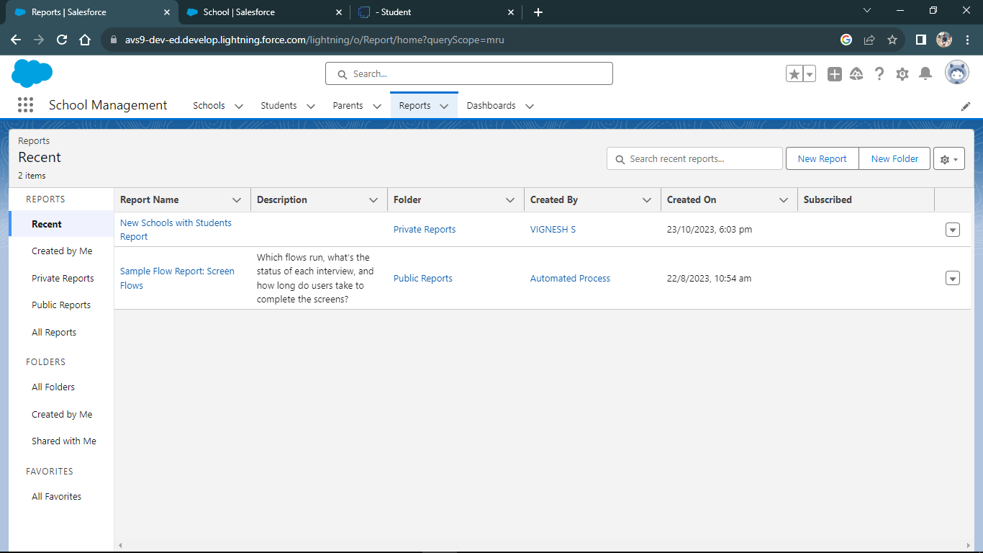

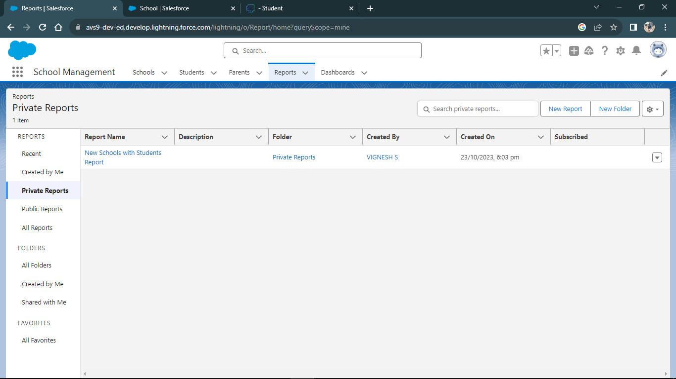

# CHAPTER-5 CONCLUSION

In conclusion, the development of an School Management application for corporates is a critical step towards streamlining and enhancing the school management process within organizations. This application serves as a centralized, efficient, and user-friendly tool for managing employee travel requests, approvals, and associated processes.

In building an employee travel approval application, it's essential to engage relevant stakeholders, including HR, finance, and IT teams, to ensure that the application aligns with organizational goals and requirements. Furthermore, thorough testing and training should be conducted to guarantee a smooth and successful implementation.

By addressing these key points and creating a tailored school management application that aligns with the unique needs and policies of the corporate, organizations can enhance their travel management processes, improve cost control, and provide a more satisfying experience for employees and travel administrators alike.

**Github:**

# CHAPTER-6 PROJECT DEMONSTRATION

[**https://github.com/Vigneshsubr/Salesforce-4747-44B330481FBEA789D3D44DF002457A7A**](https://github.com/Vigneshsubr/Salesforce-4747-44B330481FBEA789D3D44DF002457A7A)

**Demo Link:**

<https://youtu.be/oS1BzbjoCb8>